OptiCrop: Smart Agricultural Production Optimization Engine

Project Description:
The Crop Recommendation System is a Machine Learning-based web application that helps farmers choose the most suitable crop based on soil nutrients and environmental conditions. The application predicts the best crop by analyzing important agricultural parameters such as Nitrogen (N), Phosphorus (P), Potassium (K), temperature, humidity, soil pH, and rainfall.
The system is developed using Python, Flask, HTML, CSS, and Machine Learning. A Logistic Regression model is trained on agricultural datasets and saved using Pickle. The Flask backend receives user inputs, processes them through the trained model, and returns the recommended crop instantly.
The application provides an easy-to-use interface where users can enter field conditions and receive accurate crop recommendations. This helps improve agricultural productivity, reduce crop failure, and support data-driven farming decisions.

Scenarios
Scenario 1:
A farmer enters the following soil details:
- Nitrogen: 90
- Phosphorus: 42
- Potassium: 43
- Temperature: 21°C
- Humidity: 82%
- pH: 6.5
- Rainfall: 202 mm
The system predicts Rice as the most suitable crop based on the given environmental conditions.

Scenario 2:
A farmer from a dry region enters:
- Nitrogen: 70
- Phosphorus: 50
- Potassium: 40
- Temperature: 30°C
- Humidity: 55%
- pH: 7.1
- Rainfall: 75 mm
The application recommends Maize, which grows well under these climatic conditions.

Scenario 3:
A farmer provides:
- Nitrogen: 35
- Phosphorus: 25
- Potassium: 30
- Temperature: 27°C
- Humidity: 65%
- pH: 6.8
- Rainfall: 110 mm
The system predicts Cotton as the best crop and displays the recommendation within seconds.

Technical Architecture

Description
The Crop Recommendation System follows a three-layer architecture.
The Presentation Layer consists of HTML, CSS, and JavaScript pages that collect user inputs through an interactive web interface.
The Application Layer is developed using Flask. It validates the user inputs, loads the trained machine learning model (model.pkl) and scaler (scaler.pkl), processes the data, and performs prediction.
The Machine Learning Layer contains the trained Logistic Regression model built using Scikit-learn. The model predicts the most suitable crop based on the input parameters.
The prediction result is sent back to the Flask application and displayed on the webpage.

Architecture Flow

User
│
▼
HTML/CSS Web Interface
│
▼
Flask Application
│
▼
Input Validation
│
▼
Feature Scaling (scaler.pkl)
│
▼

Machine Learning Model (model.pkl)
│
▼
Crop Prediction
│
▼
Recommended Crop Displayed to User

Pre-requisites
Before developing and running the Crop Recommendation System, ensure that the following software, tools, libraries, and technologies are installed and understood:
- Python 3.10 or later – Used for implementing the machine learning model and backend logic.
- Flask Framework – Used to develop the web application and handle client-server communication.
- Machine Learning Concepts – Basic understanding of classification algorithms, model training, and prediction.
- Scikit-learn (sklearn) – Used for data preprocessing, model training, evaluation, and prediction.
- Pandas – Used for loading, cleaning, and manipulating the agricultural dataset.
- NumPy – Used for numerical computations and array operations.
- Matplotlib & Seaborn – Used for Exploratory Data Analysis (EDA) and data visualization.
- Jupyter Notebook – Used for data preprocessing, model building, and performance evaluation.
- HTML5 – Used to create the web pages and user interface.
- CSS3 – Used for styling and designing the web application.
- JavaScript – Used to improve user interaction and form validation.
- Visual Studio Code (VS Code) – Used as the development environment for coding and debugging.
- Git & GitHub – Used for version control and project management.
- Pickle – Used to save and load the trained machine learning model (model.pkl) and scaler (scaler.pkl).
- Web Browser (Google Chrome/Microsoft Edge) – Used to access and test the Flask web application.
- Windows/Linux Operating System – Supported platform for development and deployment.

Required Python Libraries

pip install flask pip install pandas pip install numpy
pip install scikit-learn pip install matplotlib pip install seaborn pip install joblib

Milestone 1: Project Setup

Step 1: Project Structure

Content:
The Crop Recommendation System project was created using Python and Flask. The project contains the machine learning model, dataset, templates, and application files. The folder structure is organized to separate the backend, frontend, and machine learning resources.

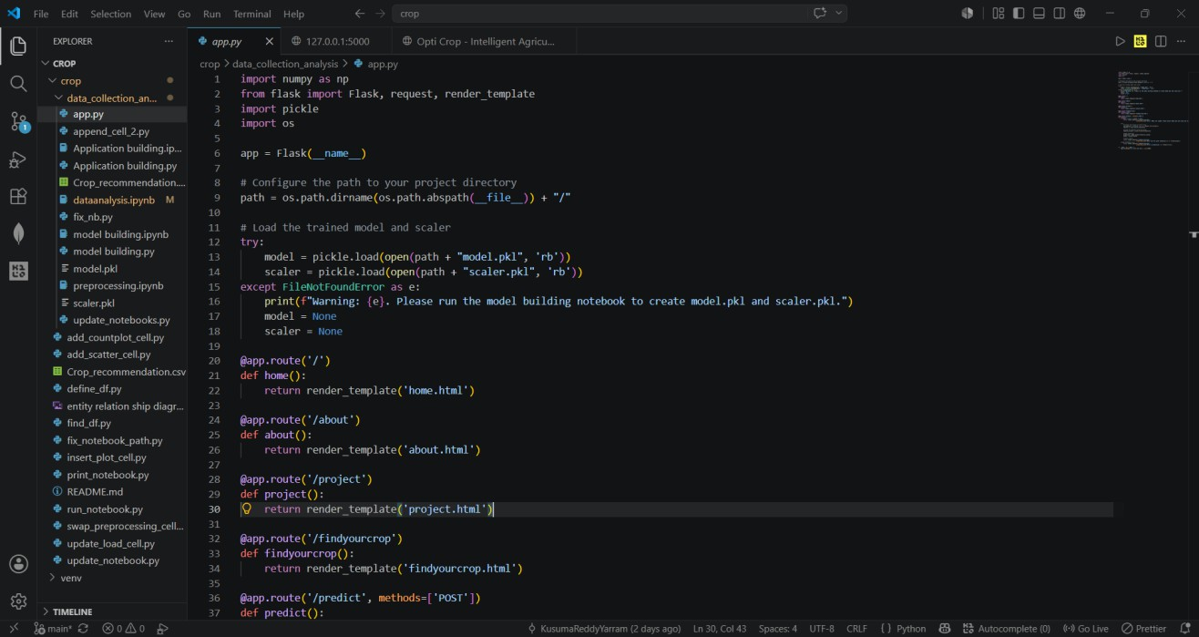

Step 2: Create Virtual Environment
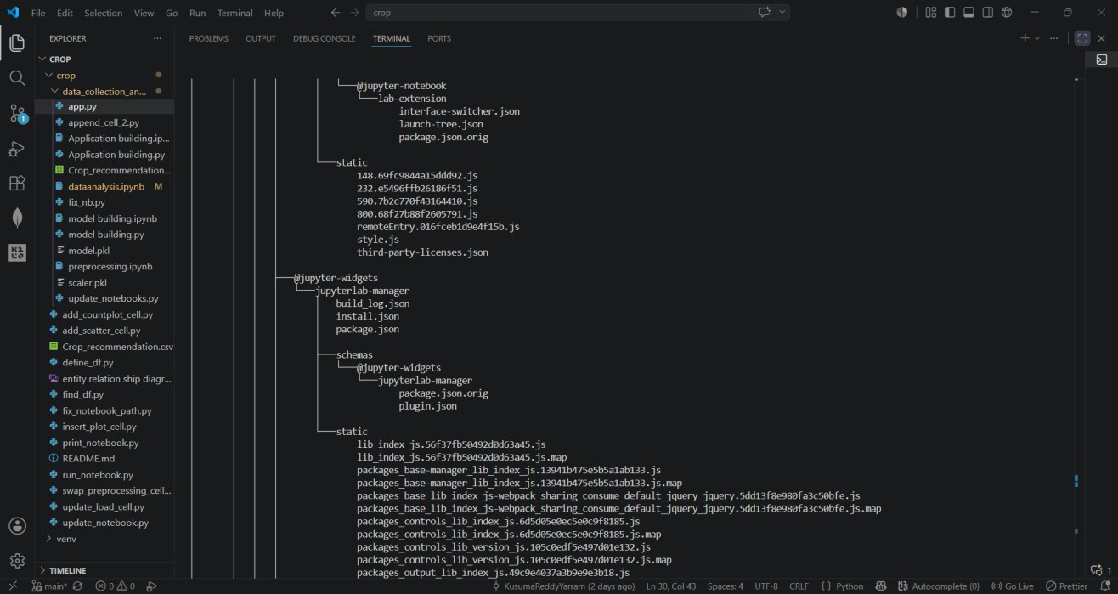

Step 3: Install Required Libraries Command:
pip install flask pandas numpy scikit-learn matplotlib seaborn

Milestone 2: Machine Learning Model Step 1: Dataset
Content:
The crop dataset contains soil nutrients and environmental parameters such as Nitrogen, Phosphorus, Potassium, Temperature, Humidity, pH, Rainfall, and Crop Label. This dataset is used to train the machine learning model.

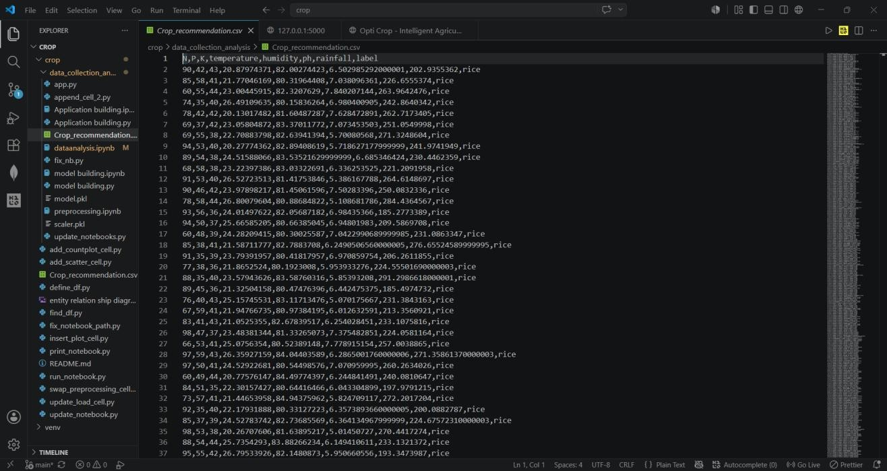

Step 2: Model Building Content:
The Logistic Regression algorithm is used to train the crop recommendation model. After training, the model is saved as model.pkl and the scaler is saved as scaler.pkl for future predictions.

Milestone 3: Flask Application Development Step 1: Backend Development
Content:
The Flask application loads the trained machine learning model and provides routes for the Home, About, Project, and Crop Prediction pages.

Code
from flask import Flask

app = Flask( name ) @app.route("/")
def home():
return render_template("home.html")

@app.route("/predict", methods=["POST"]) def predict():

Step 2: Run the Application
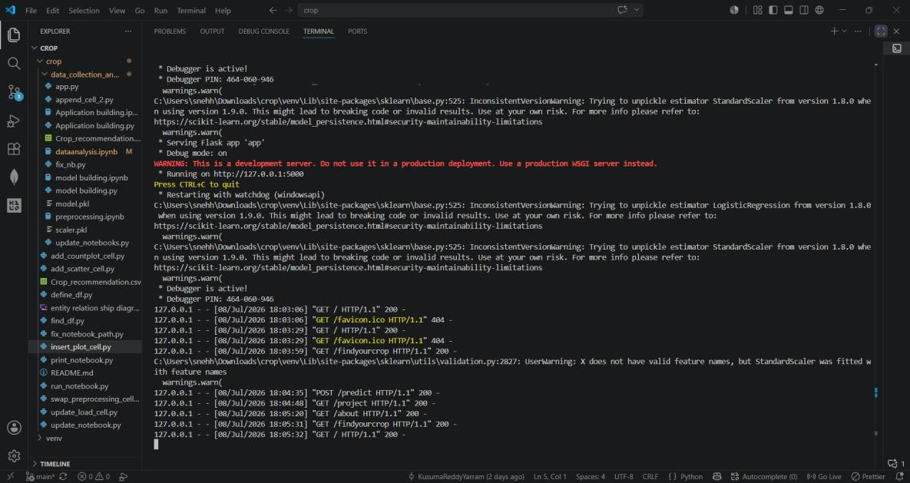

Milestone 4: Website Interface Home Page

Description:
The Home page introduces the OptiCrop Crop Recommendation System. It provides navigation to different sections and explains how machine learning helps farmers choose suitable crops.
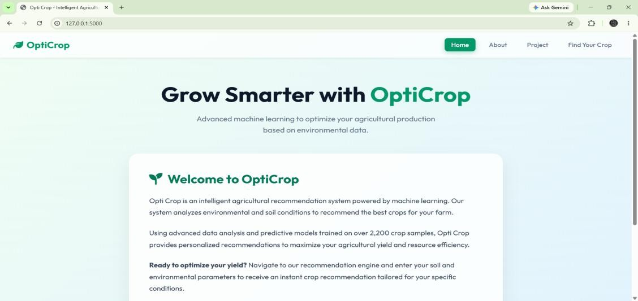

Find Your Crop Page

The Find Your Crop page allows users to enter soil nutrients and environmental parameters such as Nitrogen, Phosphorus, Potassium, Temperature, Humidity, pH, and Rainfall. These values are submitted to the prediction model.
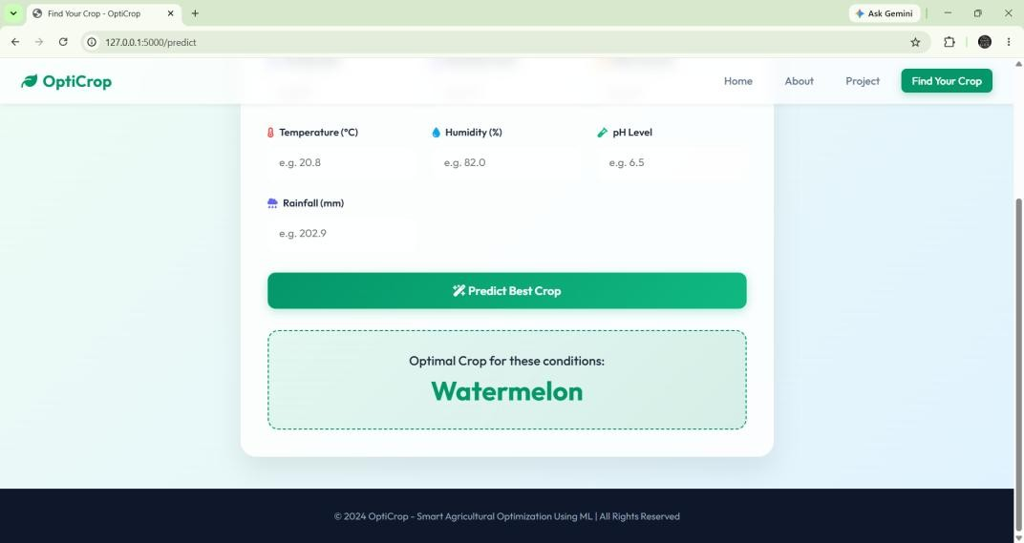

Prediction Result

After entering the required values, the machine learning model predicts the most suitable crop and displays the recommendation instantly.


